EXTRUDEX presents Vacuum Control Unit VR-3 for Extrusion Calibration Baths

Vacuum calibration bath with artificial intelligence

Visitors to FAKUMA can obtain information about the new EXTRUDEX extrusion technologies in Hall 6, Stand A6-6210. Among them, in particular, is the control unit VR-3, producing a consistent vacuum in the calibration bath of an extrusion line – automatically.

When in mode “Maintain Constant Vacuum“, the fully automatic vacuum control unit VR-3, equipped with Siemens PLC (Programmable Logic Controller) and developed by EXTRUDEX Kunststoffmaschinen GmbH in Mühlacker, Germany, ensures that the pre-set vacuum value is consistently maintained throughout the entire production period. And this even with wearing seals and the inevitable reduction in pump performance caused by warming. The VR-3 is operated via a touch display. Its programmable logic controller automatically ensures:
- Vacuum generation via venturi systems,
- Fully automatic vacuum constancy,
- Outer diameter regulation by means of vacuum control,
- Process water temperature regulation,
- Generation/retrieval of important process data.
The control permanently compares the set value with the actual value, registered most precisely via the digital vacuum sensor. Should the pre-set value deviate by >5 mbar, the control intervenes immediately and automatically adjusts the actual reading to the set value via the VR-3. The available vacuum actual values for the individual product, together with the actual values of the cooling water can be stored reproducibly in the primary PLC control. Consequently, this provides a reliable process control by obtaining continuous stabilizing control measurements combined with a complete process data acquisition and registration.

An additional advantage: When in mode “outer diameter control”, it ensures that the tube diameters can be maintained within pre-set tolerances, engaging a laser measuring head. If, for example, the outer diameter tends towards the upper tolerance value, the vacuum control valve reduces the vacuum minimally until the diameter returns to the optimum production dimensions. Decreased vacuum means smaller diameter and vice versa.

Also integrated into the control is a direct temperature control function at the display, monitoring set values by means of regulated cooling water temperature and central overflow (open cooling system). In case a customer operates equipment with a pressure cooling system, the addition of an optional circulation pump serves to independently regulate the process water temperature in the vacuum bath. This has the advantage – with a large cooling system – that the optimum process water temperature can be set to suit each extrusion line in operation individually. In addition, it is possible to integrate an optional heat exchanger in the vacuum tank. This addition is necessary when cooling circuit and processing water must not come into contact with one another. An example of this is the production of tubes used for dialysis and intravenous transfusions where the process water must be ultrapure, (i.e. free from bacteria and any substances causing infection). The cooling water must remain separate from the process water. For that reason, cooling takes place using a stainless steel heat exchange unit with FDA (Food and Drug Administration) validation.

The vacuum control unit VR-3 can be retrofitted to existing vacuum calibration baths at any time.

About EXTRUDEX GmbH
EXTRUDEX Kunststoffmaschinen GmbH, based at Mühlacker in Germany, was founded in June 1985 by Helmut Wahl. Over the past 27 years, the company has developed to one of the globally leading manufacturers of single screw extruders as well as complete extrusion plants. A dedicated and competent team of 20 employees develops, plans, designs, builds and delivers EXTRUDEX systems to customers worldwide. Among the remarkable new developments is – in particular – the HELIBAR® single screw extruder. The energy balance can – compared with conventional extruders – be improved by 10 to 60 percent, due to the reduced need for cooling and the compact machine design with the same output. In addition, EXTRUDEX GmbH has made a name for itself worldwide for the production of economic and high-precision extrusion systems for the manufacture of filigree multi-lumen catheter tubes.

Text: 4338 characters (incl. spaces), 647 words

Photos: (EXTRUDEX).

- Siemens-PLC (Programmable Logic Controller) with vacuum control VR-3

Ref: 12-18-02, August 2012, www.pr-portfolio.de

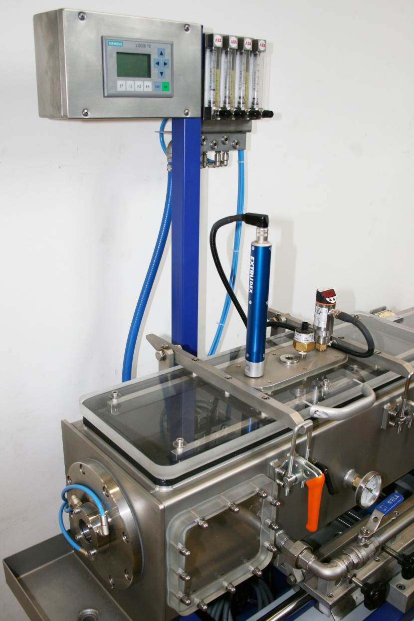
Siemens PLC with cacuum control VR-3.

